DISSERTATION BY STEPHEN SHIELLS.

BA HONS FINE ART.

UNIVERSITY CAMPUS SUFFOLK 2014/15.

APPROPRIATION, EXPLOITATION AND MONEY

IN THE LIFE AND WORK OF DAMIEN HIRST.

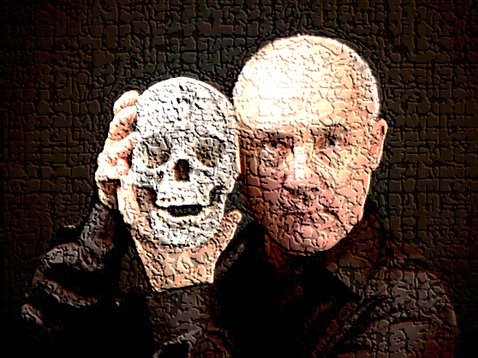

CONTENTS:

PAGE 4. LIST OF ILLUSTRATIONS.

PAGE 5. CHAPTER 1. INTRODUCTION.

PAGE 6. CHAPTER 2. BACKGROUND.

EARLY YEARS.

LONDON, GOLDSMITHS FREEZE.

CHARLES SAATCHI and COMMERCE.

HIRST DEATH AND DISGUST

THE PLAGIARISM.

SAATCHIS DEPARTURE.

PAGE 14. CHAPTER 3. THE FEATURED WORKS.
THE PHYSICAL IMPOSSIBILITY OF DEATH IN THE MIND
OF SOMEONE LIVING.
THE WORK
THE DECOMPOSITION.
THE SALE.
THE APPROPRIATION.

PAGE 16. SPOT PAINTINGS.
THE WORK.
THE PLAGIARISM.

CHAPTER 3. CONTINUED:

PAGE 18. PHARMACY.
THE BEGINNING.
THE APPROPRIATION.
THE WORK.
THE RESTAURANT.

PAGE 21. FOR THE LOVE OF GOD.
THE WORK.
THE APPROPRIATION.
THE SALE.

PAGE 24. CHAPTER 4. CONCLUSIONS.

PAGE 26. APPEDIX 1.

PAGE 28. BIBLIOGRAPHY.

LIST OF ILLUSTRATIONS.

1. “The Art Damien Hirst Stole” (various images).
2. White Cube Gallery, London.
3. D. Hirst, 1988. Boxes.
4. Saatchi Gallery, Boundary Rd. London.
5. D. Hirst, 1990, A Hundred Years.
6. D. Hirst, 1990, A Thousand Years.
7. D. Hirst, 1993, Mother and Child Divided.
8. D. Hirst, The Physical Impossibility Of Death In The Mind Of Someone Living.
9. M. Duchamp, 1917, Fountain.
10. D. Hirst, 1991, Abalone Acetone Powder.
11/12. R. Dixon, True Daisy 1991 and D. Hirst, 2000, Valium.
13/14. D. Hirst, 1989 Sinner. and D. Hirst, 1988, Enemy.
15. D. Hirst, 1992, Pharmacy.
16/17. J. Cornell, 1943, My Way. and D. Hirst, 1991, Pharmacy.
18. Pharmacy Restaurant, London.
19. D. Hirst, 2007, For the love of God. (Skull)
20/21. D. Hirst, 2007, Skull and J. LeKay, 1993, Spiritus Callidus.

Note: Dimensions of works are shown on the images.

CHAPTER 1. INTRODUCTION.
This dissertation will explore appropriation and exploitation and the influence of money, in the life and work of Damien Hirst, the Icon of contemporary, conceptual art. The social/economic and political environment during the 1980s and 1990s will be examined, from a historical perspective, along with its potential influence on Hirst and his rise to fame and fortune.
The use of the word Plagiarism avoids the suggestion that Hirst violated the legal rights of other artists. The Oxford Dictionary defines plagiarism as: ‘the wrongful appropriation for purloining and publication as one's own, the ideas, or the expression of the ideas of another.’ Taken from the Latin word Plagiarius (Kidnapper), it is the opposite of originality, and is considered an immoral, not an unlawful or illegal act.
Research will be directed to academic and professional publications and specific reference will be guided towards a selection of Hirst’s works including:

The Physical Impossibility of Death in the Mind of Someone Living (1991) - Spot Paintings (1986-2014) - Pharmacy (1992) - For the Love of God (2007) and their overwhelming influence within the Contemporary Art-World over the last 25 years.

This dissertation is sympathetic to the Stuckist voice and the effect of readymade conceptual art on painting will also be discussed. The images shown in Appendix 1 were published on the Stuckist website in 2010, by co-founder Charles Thomson (Thomson, 2010). Thomson called his piece ‘The Art Damien Hirst Stole’, and it provides a portrayal of Hirst’s appropriations. They will not be examined individually, but are submitted in support of the research. Thomson also published the following statements made by Hirst:

‘In 1995, Hirst defended his work with the rationale’ - ”It didn't exist until I did it."
‘In 2000, Hirst said’ - "I don't think the hand of the artist is important.”
‘In 2006 he said’ - “We were a generation where we didn't have any shame about stealing other people's ideas. You call it a tribute.”
‘In 2009 when questioned about his plagiarism, he said’ - "Fuck em all.” (Thomson, 2010).
Hirst’s statements show that he claims to be the originator of the appropriated work, despite considerable evidence to the contrary. He sees nothing wrong with theft, as if to excuse his plagiarism, and although he acknowledges the need to ‘tribute when ‘stealing’ he completely fails to do so. His final comment shows a total disregard for integrity and the rights of others.
Hirst has amassed a fortune of almost £300 million in only 22 years (Spalding, 2011.p 67), yet questions continue to be asked about the originality and authenticity of his work. Author Julian Spalding questioned Hirst’s work as art, and wrote in his book Con-Art Why You Should Sell Your Hirsts While You Can:
‘Ian Wilmut and Keith Campbell, who cloned Dolly the sheep, never dreamt of calling her a work of art, but she was an extraordinary creation. Damien Hirst put a sheep in a case and sold it for £2.7 million, though it was neither a work of art, nor in any sense his creation’ (Spalding, 2011).
One view could be that this statement questions Hirst’s legitimacy as an artist. His plagiarism is not borrowed from the past, but is performed at the cost of living artists and this notion will be explored in the body of the text.

CHAPTER 2. BACKGROUND
2.1.0 THE EARLY YEARS.
Damien Hirst was born in Bristol in 1965, and spent his childhood in Leeds, where he discovered that his next-door neighbour, Mr Barnes, would collect detritus from the streets and arrange and catalogue it in his home (Muir, 2009 p37). Hirst would visit Barnes’s empty house and take items for his own use. He described himself as an ‘uninvited guest’ (Hirst/Burn, 2001) and that experience had a profound effect, which still haunts him today (Thomson, C. webpage 2010).
In 1997, during an interview with Stuart Morgan, an influential art critic. Damien Hirst said:
‘There was no doubt that Barnes’s building was meant to be regarded as a kind of monument. As such it had not one but an overlay of histories: the record of its conception, construction, use, symbolic significance, state of existence (complete or partial), not least its reception and access, restricted in this case to Barnes himself and a few uninvited guests who witnessed it before its destruction’ (Morgan, 1996).
It appears that Hirst is romanticising a very ordinary event, by describing Mr. Barnes house as a ‘monument with symbolic significance.’ It was in fact just an ordinary council house, filled with rubbish and the local council eventually cleared it and dumped the entire contents onto the street (Muir, 2009). This pretentious description is invoked from Hirst’s childhood memories, it typifies the method used to label his work, and can be seen as an attempt to elevate otherwise mundane events.

2.1.1. LONDON, GOLDSMITHS AND FREEZE.
After moving to London in 1986, Hirst found his way to the Fine Art Degree at Goldsmiths College, where tutors Michael Craig-Martin and Richard Wentworth provided revolutionary direction and guidance in contemporary practice, which included lectures in gallery awareness, and focused on conceptual ideas rather drawing and painting (Gallagher, 2012 p12). Goldsmith’s radical methods have been questioned by respected art-world figures, such as Turner Award Nominee George Shaw - RCA 1988, who:
‘Became incredibly frustrated with the need for a philosophical language, rather than a pictoral one, to understand this new conceptual art’ (Shaw, In - Smart, 2012).
Renowned contemporary artist David Hockney would echo Shaw’s views by questioning the conceptual philosophy as ‘insulting to skilful craftsmen,’ adding:
‘You can teach the craft, it’s the poetry you can’t teach. Now they try to teach the poetry and not the craft’ (Hockney in Smart, 2012).
Shaw highlights an issue with the understanding of conceptual language, which is shared by many others within the art-world, and painter Hockney describes how conceptualism lacks the craft, or skill normally associated with fine art.

A consequence of the commercial success of readymade conceptualism is the ridicule and suffocation of painting. Stuckism was born from a Tracey Emin insult to her boyfriend painter Billy Childish, by calling him ‘Stuck, Stuck, Stuck.’ Childish and Charles Thomson were so driven to found the Stuckist Movement of contemporary figurative painters in 1999 and in an interview with Tate Sound and Vision in February 2010, Childish said:

‘I don’t have a problem with conceptual art per se. I have a problem with what I term as Banker’s Dada, and that would be conceptual art done specifically to meet a market demand (Tate Sound and Vision, 2010).

This comment highlights the commercial focus which forms a major part of Hirst’s motivation.

Hirst attended his Fine Art Foundation in Leeds in 1983, where he was drawn to collage. He had not excelled at drawing or painting, and was more comfortable in his journey towards installation, collage, and sculpture (Muir, 2009 p37).

’I tried to be a painter but couldn’t do it. I always had this white void which screwed me up.’ (Hirst/Burn, 2001 p18).

The practice of ideas and conceptions, therefore suited Hirst’s capabilities, and conceptual sculpture and installation would become his trademark. (Spalding, 2011. P433).
In 1988, during his second year at Goldsmiths, Hirst showed a talent for self-promotion when he curated his own exhibition called Freeze. Finding the space, raising the finance and organising the shows, all came naturally and he never saw it as revolutionary, it was just common sense to him. Hirst never believed that anyone would attend Freeze, but it was a success and turned out to be a landmark show, where a generation of Goldsmith artists joined forces for the first time (Hirst/Burn, 2001 p16).

2.1.2 CHARLES SAATCHI AND COMMERCE.
Freeze provided an early indication of Hirst’s commercial drive and the group of participating artists would soon become part of what became known as the Young British Artists led by Hirst and sponsored by Charles Saatchi from 1991 (Muir, 2009 p18). Saatchi was well known as a collector of American contemporary art during the 70s and 80s and when he saw Hirst’s work, including A Hundred Years and A Thousand Years, at the Gambler exhibition in 1990, he was inspired to abandon his American favourites, such as Jeff Koons, and focus on his sponsorship of Hirst and the Young British Artists (Thompson, 2008 p94).
The YBA’s work consisted of a diversity of radical conceptual art and Saatchi’s financial and marketing support would enable the YBA label to become a powerful brand and marketing tool. (Thompson, 2008 p95). Artists made use of video and photography, installation, dead animals, found/readymade objects and Tracey Emin presented her own unmade bed as a work of art. (Tate Learn, 2007).
Jay Jopling, an art dealer with money and establishment contacts and owner of the original White Cube Gallery, became Hirst’s dealer and supported by Saatchi and Jopling, Hirst Etonian Jopling came from a privileged background with a hunger to establish himself, and made the White Cube a focus for new British talent. (Spalding, 2011. P894). One view could be that Saatchi and Jopling were crucial influences on Hirst and their financial support and contacts provided the young artist a unique opportunity to flourish.
2. 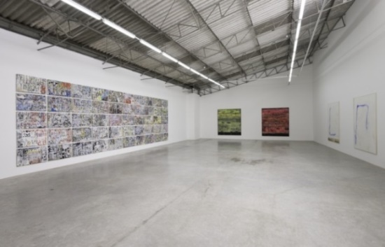
White Cube Gallery, Duke St London.
At that time, Hirst’s work was not as shocking as it would become. His arrangement of Boxes shown at Freeze, was quietly inoffensive, constructed from household gloss paint on cardboard boxes and measuring 173 x 262 cm, from a collection such as he took from his childhood neighbour, Mr Barnes.
3. 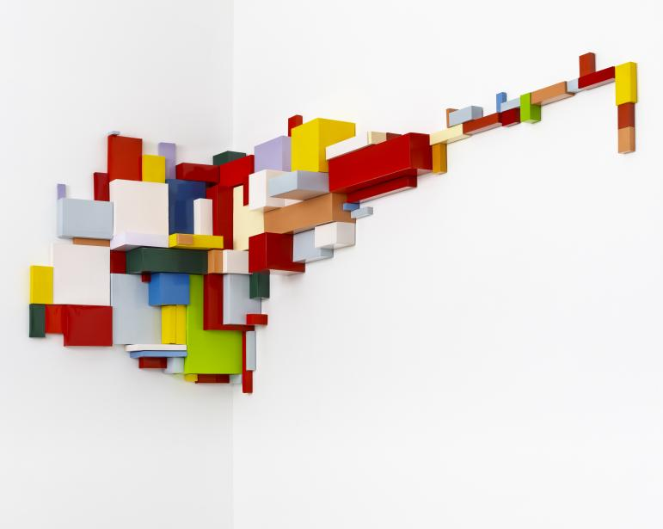
Boxes, D. Hirst, 1988. 173 x 262 cm

Hirst’s first Spot Paintings called the works ‘Edge’ (1988) and ‘Row’ (1988), were also displayed for the first time at Freeze and were presented as coloured pill like dots painted directly onto the gallery walls. (Hirst, 2012).
Hirst was one of the last of the Freeze generation to secure gallery representation and it was not until his first solo show, at the Institute of Contemporary Arts, London, in 1991, that his obsession with shock and death would become evident (Muir, 2009 p123-125).
The self-confident students from Goldsmiths were spurred on by the economic recession of the late 80’s early 90’s, and emerged to promote themselves in the face of the unemployment and economic uncertainty of Margaret Thatcher’s early government of 1979.
Saatchi’s marketing and branding talent helped secure crucial election victories for Thatcher’s Conservative Government, with radical, pioneering advertising campaigns (Fallon, 2007) and Hirst’s emergence ran in parallel with Thatcher’s acrimonious reign from 1979 to 1990 (Spalding, 2011. P433). Her confrontational policies created high levels of unemployment from the demise of Britain’s industrial foundation. She was the first female Prime Minister of Great Britain and she contemptuously destroyed the domineering influence of militant Trade Unionists, who had wrestled control of the country from the previous Labour Government (Coman, 2013).
Popular images of that time showed young city traders and bankers with ‘loads-a-money’ to be the icons of Thatcher’s free-market, capitalist ideology and this can be seen as the ideal environment and inspiration for Hirst’s commercial focus. If we ask why Maggie Thatcher won her first and subsequent election victories, one analysis could be that:
(a) The British public were sick and tired of the debt and desolation caused by Harold Wilson’s Labour Government of the 70’s and were desperate for change.
(b) Charles Saatchi’s genius and innovation, successfully branded Thatcherism.
If we then ask how Damien Hirst became so rich and famous, it can be argued that:
(a) That the art world was desperate to have a new label to adore, as the money culture evolved.
(b) Saatchi’s branding genius was decisive in Hirst’s launch and commercial development.
These parallels can be seen to have one essential common ingredient, Charles Saatchi, who succeeded in creating the commercially minded Hirst. He brought Hirst to the fore in 1991, with his record £50,000 commission for The Physical Impossibility of death in the Mind of Someone Living (The Shark) showing it at two major exhibitions, The Royal Academy of Art in 1997, and Berlin and New York (Wainwright, 2013).
Saatchi took a contingent of YBA’s to the Cologne Art Fair in 1993, which, was their first overseas show, and featured Hirst’s The Physical Impossibility… in Saatchi’s British Central Arena. The work attracted great interest and confirmed Hirst’s status as an international celebrity (Muir, 2009 p123-125).
Hirst therefore found himself in a very privileged position, simply by being in the right place at the right time with a unique opportunity to access, finance, marketing and branding, which enabled the sale of his work for vast sums of money, on an international scale (Spalding, 2011. p433).
Saatchi established a London Gallery in the 1980’s, which became well-known for showing unconventional contemporary work, by largely American artists. It was a visionary concept, providing Cathedral like white space on an incredible scale, and the work exhibited showed London and the rest of the world how to present contemporary art in the best possible contemporary surroundings (Thompson, 2008 p93-95).
4. 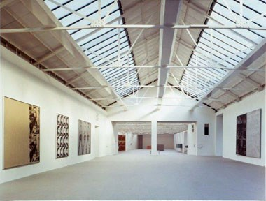 Saatchi Gallery, Boundary Rd.
Another important step for Hirst, in 1998, was his association with gallery owner Larry Gagosian, the world's most powerful art dealer, who was responsible for the sale of The Physical Impossibility…. in 2005 (Batty, 2013). Gagosian, became responsible for the representation of some 77 artists in 11 worldwide galleries, and alongside Jay Jopling was said to have propped up the prices of Hirst’s ground-breaking 2008 auction, by making bids or purchases worth almost half the auction's £70million first-day sales (Spalding, 2011. P894).).
One way of viewing this is that this dealing was financial manipulation of the art market for Hirst’s and their monetary benefit, on a scale that had not been seen before and we see the art-world being exploited for financial motives.

2.1.3. HIRST’S DEATH AND DISGUST.
In 1990, Hirst made A Hundred Years and A Thousand Years, which are floor-based constructions of glass, steel, silicone rubber, painted MDF, insect traps, flies, maggots, metal dishes, cotton wool, sugar and water. A Thousand Years, included the addition of a real cow’s head, to give the flies something to feed from. They were the introduction to his association with death, shock and disgust, and caused an upset in the art-world at the time (Dorment, 1992). Arguably, these works were not art at all and were better suited to exhibit at the Natural History Museum, rather than the Tate. Ann Gallagher of the Tate questioned the presence of “Disgust” in Hirst’s work by saying:
‘Disgust is not just an intrusion into the realm of art that renders the object or image less beautiful or less artistic; it actually does away with the works ambition to the status of art in the first place’ (Gallagher, 2012. p 25).
This statement can be interpreted as questioning the place and status of ‘disgust’ in art, some 22 years after Hirst’s work was accepted, and asks why it was recognised in the first place.
5. 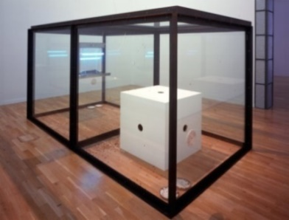 6. 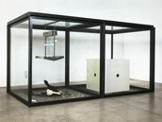
A Hundred Years – D Hirst 1990 A Thousand Years – D Hirst 1990. 213x426x215 cm 207x400x215 cm .
The works were acknowledged by Hirst as the most important works of his career and their commercial success showed him that disgust and shock tactics worked (Dorment, 1992).
Hirst was awarded the Turner Prize in 1995, for his work Mother and Child Divided, which portrayed more floor based tanks containing dead animals in formaldehyde, This once esteemed prize had become ‘a joke’ (Hudson, 2014) and was seemingly swept up in the excitement surrounding the YBA’s, and for the next 20 years, painters would be virtually excluded from the list of Turner prize-winners (Hudson, 2014).
One view could be that this was not art, but another work best suited to the Natural History Museum, as it was another of Hirst’s plagiarisms and merely informed the viewer about a cow’s anatomy. Numerous voices have been raised in objection to conceptual art, including Chairman of the Institute of Contemporary Art, Ivan Massow, who stated that:
‘Conceptual art was pretentious, self-indulgent craftless tat’ and ‘the art establishment, led by the head of the Tate empire Nicholas Serota, had turned conceptual art into the totalitarian state art that all young artists must conform to if they were to succeed.’
The ICA board called him a ‘pillock’ and he was forced to resign in 2002 (Gibbons, F. 2002), but Massow is a man to be admired for expressing his unfashionable views, despite the inevitable ridicule. The insistence that all young artists conform to conceptualism, unfortunately continues today, although those concepts are now 25 years old and in need of change.
7. 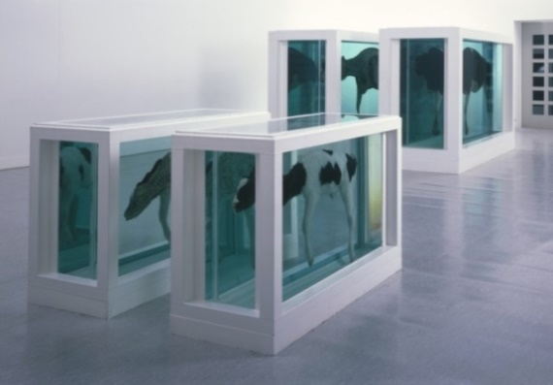
Mother and Child, D. Hirst 1993. 190 x 322 x 109 cm. and 103 x 167 x 62 cm.

2.1.4. THE PLAGIARISM.
In 2007, artist John LeKay accused Hirst of plagiarising the cow, claiming that in 1992, they had discussed Lekay’s reference to the Carolina Biological Supply Company catalogue. He had shown Hirst a marked-up copy displaying a cow divided in two, which he intended to use as a subject for his own work. LeKay had also shown him a work titled, This is my body. This is my blood. 1987, which featured the body of a sheep cut open and hung as if crucified. Hirst produced his own version of this work in 2005 and called it: In nomine patris (In the name of the father’ (Thomson, 2010).
The unfortunate LeKay’s appears with regularity on author Thomson’s list of Hirst’s ‘stolen work,’ but Hirst never acknowledged the artist’s contribution (Thomson, 2010). It could be interpreted that Hirst took advantage of Lekay’s friendship during the 90’s and LeKay became an unwitting source of reference and appropriation for a number of Hirst’s works. Regrettably, LeKay became fearful of displaying his own work, in terror of being accused of copying the famous Hirst (Thomson. 2010).
One view might be that this is an example of Hirst’s commercial exploitation of contemporary artists, by his plagiaristic disposition and his blatant disregard for others.

2.2.0. HIRST-SAATCHI THE END.
Through his association with Saatchi, Hirst gained the financial power to dictate his own terms, building his Brand and gaining enemies as well as friends along the way. Hirst ensured that no-one took advantage of him and was confident enough to turn the tables on the greedy establishment as exploitation became his to impose (Muir, 2009 p37),
Hirst’s fame and fortune relied on Saatchi’s business, marketing and branding genius, but his relationship with his commercial mentor Saatchi, soon ended (Smart, 2012). In 2003, Saatchi turned away from his own creation of the vast, pristine white space, opting for the warren like oak-panelled interior of London County Hall and the relationship with Hirst came to an end when he became unhappy with the way his work was displayed (Saatchi, 2009 p123).
Hirst disliked this environment, as it didn’t show his work as he expected. In a vindictive act, he bought back his works from Saatchi to arrange a sale, through Saatchi’s main rival, Jay Jopling (Spalding, 2011. p734). Saatchi commented that:
Damien Hirst is a very insecure and frightened man. t's a wonderful reversal of roles. The artist has become so rich that he can buy his work back off his patron.’
Hirst replied:
‘Mr Saatchi is a childish businessman who only recognises art with his wallet.’ (Spalding, 2011. p734).
One interpretation could be that Saatchi was patronising Hirst with his comment, but Hirst, failed to acknowledge the unique opportunity given him by Saatchi’s sponsorship and he belittled his mentor.
Saatchi eventually admitted his error in moving to County Hall (Saatchi, 2009. P123) and opened a glamorous new gallery at the Duke of York's HQ building, King's Rd, London, in 2008, where he can now be seen to celebrate painting again, giving new artists the opportunity to submit their work for sale online (Saatchi, 2009. p82-83).
In September 2008, Hirst took an unprecedented move for a living artist by selling a complete show of 244 pieces called Beautiful Inside My Head Forever. This direct auction at Sotheby's by-passed his long-standing galleries and exceeded all predictions, raising £70 million. It broke the record for a one-artist auction, only hours ahead of the worldwide financial crash of 2008 (Muir, 2009 p191)
History shows that this was a phenomenal stroke of luck for Hirst, as it was completed on the eve of an unparalleled world-wide financial recession. However, the value of his work subsequently plummeted alongside a repressed marketplace, but Hirts had already banked his fortune (Spalding, 2011, p894).
In 2009, prices for Damien Hirst’s work had plummeted. Auction sales and the average price levels for his work dropped back to 2005 levels (Batty, 2013). One in three of the 1,700 pieces offered at recent auctions failed to sell at all and works sold a few years ago have since resold for 30 per cent less than their original purchase price (Batty, 2013).
By 2012 values had dropped even further and one assessment could be that Hirst’s covert sale of For The Love of God in 2008 (Batty 2013) did not work.

CHAPTER 3. THE FEATURED WORKS.
CHAPTER 3. THE FEATURED WORKS.
8.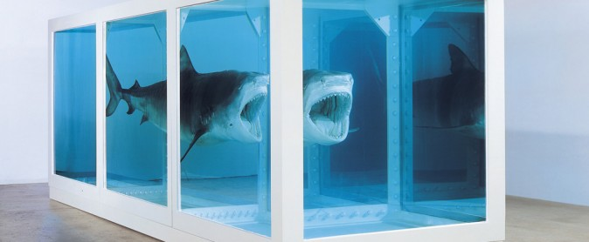
3.1. THE PHYSICAL IMPOSSIBILITY OF DEATH IN THE MIND OF SOMEONE LIVING.

3.1.0. THE WORK.
Measuring 217 x 542 x 180 cm, was created in 1991 with the vitrine container following a similar style to A Hundred Years, but with heavier steel frame section, in 3 equal cubes, bolted together. The structure is reminiscent of the ribs of a rusted, sunken vessel and the 14 foot Tiger Shark is seen immersed in a solution of formaldehyde, suspended open mouthed in a threatening pose, reminiscent of the film Jaws, and intended to provoke fear in the mind of the viewer. When asked about the title for the Shark, Hirst stated: ‘it came to mind before the work was started.’
He had written it down as part of his thesis at Goldsmiths. Hirst loved museums, but hated the zoo and decided to do a series of dead animals. (Hirst/Burn 2001 p45), After making the sculpture he put the two together, because it described what Hirst saw, as: ‘the fear of death ’ (Cicelyn, 2004 p122).
Despite Saatchi’s record commission, it was difficult for many people to accept a dead shark as art and it caused media outbursts and public outcry when it was revealed, (Muir, 2009).
The question is, why was this accredited as a work of art and not a museum piece (Spalding, 2011. p102). One view could be that, without the persuasive Saatchi’s money and promotion, it may never have been seen as art, and without the pretentious title it would simply be a shark in a tank, with no artistic merit. Critic Robert Hughes described the international art market of the 90’s, as ‘a cultural obscenity’ at a time when commerce and readymade conceptualism erupted at the expense of painting (Hughes, 2004),

3.1.1. THE DECOMPOSITION.
After only a short time on display at the Saatchi Gallery, the Shark began to decompose. The formaldehyde solution became cloudy, as a result of ineffective preservation, and in 1993, the tank was drained, the Shark was skinned and stretched over a fibreglass mould, before being immersed into more than 224 gallons of fresh formaldehyde solution (Thompson, D. 2008 p2). According to Hirst it had lost its ability to shock or frighten anyone (Hirst/Burn, 2001 p45-47).
Saatchi was not responsible for the sale of the Physical Impossibility……and when asked if the refurbishment of the rotting shark robbed it of its meaning as art? he replied: ‘Completely ’ (Saatchi, 2009 p72). This could be interpreted to mean that the work was destroyed and should never have been replaced. However, money raised its head, commercialism took precedence, and it was patched up to make a sale.

3.1.2. THE SALE.
In 2004, the sagging, renovated work was sold to New York financier Steven Cohen for $12million. Hirst offered to replace the Tiger Shark with a new one, at Cohen’s expense and when questioned about the legitimacy of this action, Hirst argued that the work was a conceptual idea and his intention was more important than the work itself (Thompson D. 2012 p69). Despite his obvious intelligence, Cohen was willing to go ahead with this corrupt arrangement and presumably thought that his money was safe.
A critical view could be that he was wrong and this was immoral and unprofessional conduct by Hirst, who appeared to be more concerned about the money than the art. Hirst has been praised by some as: ‘informing a new generation about conceptual art,’ but decried by others as ‘an artist of gimmicks and one-liners (Vogel, 2006).
However, he could be seen here, to be acting as a charlatan and parallels can be drawn with Marcel Duchamp’s equally contemptuous replacement of Fountain (Spalding, 2011. p433). Political activist Marcel Duchamp (1887-1968), arguably the most influential artist of the twenty-century, rejected all things painterly and claimed industrial readymade items as art, where the conceptual idea of his work had more importance than the work itself (Spalding, 2011. P535).
He took delight in disturbing and outraging people (Spalding, 2011. P535) and literally took the piss with Fountain1917, a factory made gents’ porcelain urinal bearing the bogus name of R. Mutt as the artist. Duchamp also disowned it as his own creation (Thompson, 2012)
The work posed a direct challenge to traditional perceptions of fine art, ownership, originality and plagiarism, and was rejected by the Society of Independent Artists exhibition committee (Spalding, 2014 p68-71).
9. 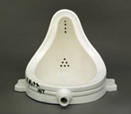 Fountain, R. Mutt (M. Duchamp) 1917 - 38 x 46 x 61cm
The original piece was lost soon after 1917 and Duchamp authorised fifteen replicas, one in 1951, 1953 and 1963 respectively and a further twelve in 1964 (Howarth, 2000).
One view is that there is a critically important overlap between Duchamp and Hirst, as neither of them can be seen to have any conscience about reproducing and selling copies of their originals, and using the excuse that their ‘ideas’ were the creation and not the work.
It can be seen that their motives were different, as Duchamp was driven by politics and a desire to destroy art and Hirst was driven by exploitation and money.
However, the result of their actions had the similar effect of damaging the credibility of art (Spalding, 2011. P535), but both were celebrated, despite their unprofessional practice, and Hirst became the personification of the contemporary art-world. In 2013, Jonathan Jones of the Guardian summed it up by saying:
Art has become our contemporary cultural signature and Hirst, our most renowned creative figure, sends out a very clear message that art is about making money from nothing’ (Jones, 2013).
This can be seen to comment of the moral ineptitude of today’s society, where money is still the major deciding factor in the valuation of everything including art. One of Britain’s finest artists Joseph W. Turner, 1775–1851, refused a fortune of £100,000 for the sale of his work, as he preferred to bequeath it to the Nation.
A traditional view would define an enormous divide between Turner, a true, suffering Master Painter who put his art first and Hirst, a clever, commercially driven technician who put money first.

3.1.4. THE APPROPRIATION.
In 2003, the Stuckism Gallery in Shoreditch London, exhibited a shark which had first been put on public display in 1989 by Eddie Saunders in his Electrical Supplies shop. The Stuckists labelled it A Dead Shark Isn’t Art and suggested that Hirst may have appropriated his idea from Saunders' shop display (Thomson, 2010 p70). Saunders was not an artist and never claimed the work as art, and it is clear that Hirst changed his version considerably from Saunders shark.
This act of appropriation by Hirst, can therefore be seen as legitimate, by borrowing from the past, and fundamentally changing the original, by the addition of a tank of formaldehyde. However, it’s value as a work of art, remains in dispute.

3.2. SPOT PAINTINGS.
10.
Abalone Acetone Powder, D. Hirst 1991 58 x 62 cm x 2 cm spots

3.2.0. THE WORK.
Spot Paintings have been one of Hirst’s chief money making series, spanning more than 25 years from 1986 and now manufactured with production line efficiency, by over one hundred gallery assistants employed in his factory (Smart, 2012). The work above is one example of almost 1,500 similar pieces which vary in size from 1.5 inches to 60 inches. They have been a major financial success for Hirst, totalling more than one thousand, four hundred sales on an international scale, with one canvas selling for £1.8million (Smart, Telegraph 2012). Hirst’s factory workers are said to currently producing a single work with two million spots, which is programed to take 9 year to complete (Smart, 2012). Arguably, this will have little artistic merit, because it will simply be a larger copy of what has gone before, to gain further commercial advantage for Hirst.
One analysis could be that it adds nothing new to the art-world and can be seen as another ‘attention seeking’ (Stallabrass, 2006 p25) marketing ploy to manufacture on a gigantic scale, to make money from the art-world Glitterati who seemingly have more money than sense (Spalding, 2011. P894).
Hirst maintains that his intention was always to create a collective installation of Spot Paintings and in his book - On The Way to Work, he explained their conception by saying:
‘It's something I've been excited about for years. Ever since I first started making them. it’s an assault on your senses. They grab hold of you and give you a good shaking. As adults, we’re not used to it. It’s an amazing fact that all objects leap beyond their own dimension. To create that structure, to do those colours, and do nothing. I suddenly got what I wanted. It was just a way of pinning down the joy of colour’ (Hirst/Burn, 2001 p82-84).
One way of analysing Hirst’s words is that he claims the spot concept as his own original thought. And he attempts to confound the viewer, to conceal his appropriation, Spot paintings were not new in the 1980’s, they had been painted many times before. Hirtst’s words can also be seen to say that he ‘enjoys doing nothing,’ and he clearly relishes the challenge and achievement of employing others to paint his coloured spots and ‘pinning down the joy of colour’ for him (Spalding, 2011. P624). Most painters live eternally with the mental pain of discovering colour with their own hands, in their quest for meaning and narrative in their work. ‘Doing nothing’ and employing others to paint simple monotonous spots on his behalf, hardly qualifies Hirst as art in comparison.

3.2.1. THE PLAGIARISM.
In 2000, Hirst made a Limited Edition of 500 production line copies of Valium, which show a swirling geometric pattern of coloured spots of inkjet print on glossy professional paper. Measuring 121 cm in diameter and sold around the world, including one at Christie’s, London, which reached the sum of £11,875 (Christys, 2012).
11/12. 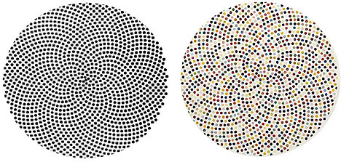
True Daisy, R. Dixon, 1991. Valium, D. Hirst, 2000.
Size unknown 121 cm diameter.
Hirst was accused of copying the work of Robert Dixon, a computer graphics artist and former research associate at the Royal College of Art. Dixon had drawn his work True Daisy in 1983, and his digital creation featured in the Penguin Dictionary in 1991, nine years before Hirst’s Valium was displayed. (Thomson, 2010).
Dixon demanded an acknowledgement of his artistic ownership and compensation from Hirst, saying in a letter In a letter him:
‘Your drawing is not merely the same pattern but is made by copying my drawing. Your artwork is practically dependent on my artwork. I conceived, calculated, formulated and programmed the Penguin drawing. You did not. Although Valium was larger than True Daisy, it was a mirror image of the design, with the same number of spots. This makes it a tracing’ (Thomson, 2010).
Hirst’s manager attempted to contest this accusation by explaining that the origin of Hirst's piece was from a book called The Penguin Dictionary of Curious and Interesting Geometry (1991), without realising that this was the same place where Dixon's design had been published (Thomson, 2010). This response can be seen as a cheap, unconsidered excuse to belittle a serious and substantiated accusation by Dixon. It demonstrates Hirst’s continued exploitation and abuse of other artists and brings into question the role of the auction house.
Other than the addition of colour, Valium is an identical copy of Dixon’s work. The arrangement of Dixon’s spots in his work render it unique and a historical view could be that it was Christy’s duty to ensure ownership before taking commission on the sale of Hirst’s work (Spalding, 2011. P894).

3.3. PHARMACY.
3.3.0. THE BEGINNING,
Hirst’s morbid curiosity for death began in early childhood discussions with his Grandmother, who played an important role in his upbringing, and from the age of seven they engaged in long conversations about death. (Spalding, 2011 p734). He became aware that all life is finite, but it could be prolonged by drugs and medicine. (Muir, 2009 p191).
In the 1988 Freeze Exhibition, he first showed a display of various drugs arranged neatly on the shelves of a medicine cabinet. Entitled Sinner, made from glass, painted faced particle board, ramin, plastic, aluminium and pharmaceutical packaging. It provided a personal portrait of his late grandmother by showing a collection of prescription drugs left on her death from lung cancer (Hirst/Burn 2001 p75).
13. 14.
Sinner, D. Hirst 1988. 137 x 102 x 23cm. Enemy, D. Hirst 1989. 137 x 102 x 23cm.
Enemy was of similar construction, but contained brand new medical packaging which Hirst intended to renew every time it was exhibited, so that it remained up to date and contemporary (Hirst/Burn 2001 p24-25). Hirst’s appropriation from the past is again apparent, as Marcel Duchamp (1887–1968) made one of his first ready-mades entitled Pharmacy in 1914 and Joseph Cornell (1903-72) created a series of very similar looking cabinets, including two entitled Pharmacy, during the 1940’s and 50’s (May, 2009).

3.3.1. THE APPROPRIATION.
There is clear reference between Cornell’s Pharmacy and Hirst’s My Way and the title has been appropriated for Hirst’s room-size version. One interpretation could be that, not for the first time, he has taken an idea and expanded it to create a commercially attractive version.
16/17. 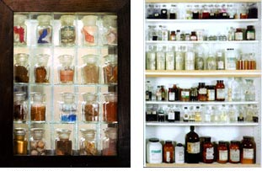
Pharmacy, J. Cornell 1943. My Way, D. Hirst 1991. 39 x 30 x 8cm. 137 x 102 x 23cm.
3.3.2. THE WORK.
Pharmacy was conceived as a site-specific installation for the Cohen Gallery, New York in 1992 (May, E 2000). The work replicated a complete, room sized pharmacy as seen in hospitals, with large cabinets covering the walls and placing the viewer directly inside the work.
15. 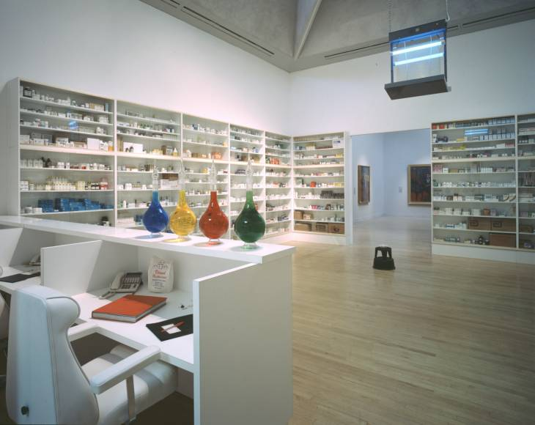 Pharmacy, D. Hirst, 1992 Roomsize
It includes a smart reception desk with 3 chairs and four coloured apothecary bottles signifying the four elements life - earth, air, fire and water, and the historic custom of treating the human body. Four bowls containing honeycomb are also seen, placed on footstools on the floor, arranged around an insect-o-cutor hung from the ceiling which alludes to the temporary relief of sickness and pain supplied by drugs and medicines’ (Dannatt, 1993 p59),
This is the central metaphor which attracts flies, only to lure them into a quick and brutal death’ (Dannatt, 1993 p59),
Hirst saw his cabinets as bodies, creating a life-size historical record which he hoped would become a contemporary museum. Drug and medicine packages were displayed on the shelves in immaculate order, with those for the head at the top; medications for the stomach on the middle shelves; and those at the bottom treated the feet (Dannatt, 1993 p59). The historical reference is evident in this immaculately presented work, relating to Hirst’s Spot Paintings, which portray different coloured pills as spots and bear the medical names of pharmaceuticals as their titles (Gallagher, 2012 p32).

3.3.3. THE PHARMACY RESTAURANT.
In 1998 Hirst lined the walls of his prestigious new Pharmacy Restaurant in Nottinghill, London, with replicas of the Pharmacy installation. The restaurant failed and was subsequently sold in 2003 and the entire contents of 114 pieces, including butterfly paintings, aspirin shaped bar stools, flask light fittings, original paintings and drawings of the artist’s design, were auctioned at Sotheby’s for £11 million in 2004 (Stallabrass, 2006 p30). One of the medicine cabinets, called The Fragile Truth, fetched £1,237,600 and a second cabinet fetched £1,069,600 (Bennett, 2004). This showed Hirst’s commercial awareness and ability to control his market by selling directly at auction rather than through dealers.

3.4. FOR THE LOVE OF GOD.
19. 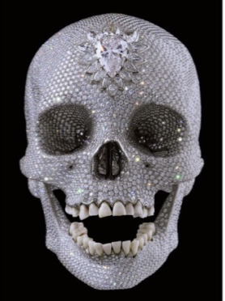 For the Love of God, Damien Hirst, 2007. 17 x 12 x 19cm
3.4.0. THE WORK.
This dramatic work was commissioned rather than created by Hirst in 2007. Designed and sculpted by Jack du Rose, a jewellery designer, it consists of 8,601 flawless diamonds weighing 1,106 carats, including a pear-shaped pink diamond, called the Skull Star Diamond, located in the forehead. The skull contains a full set of original human teeth and is set over a platinum cast of an 18th century human skull (Thompson, 2012 p75).
Manufactured by Piccadilly jewellers Bentley & Skinner it is said to have cost £14 million to produce, but Harry Levy, vice chairman of the London Diamond Club, estimated the true worth of the skull as somewhere between £7 million and £10 million (Thompson, 2012 p75-76). Only nine inches tall, but immaculately presented and named in memory of his Mother’s exclamations: “For the love of god Damien, whatever are you doing now?” the work is a very controversial financial statement by Hirst (Thompson, 2012 p75). Hirst describes the work as:
’A reminder that our existence on earth is transient. You don’t like it, so you disguise it or you decorate it to make it look like something bearable – to such an extent that it becomes something else.’ (damienhirst.com).
These words are a small part of a long narrative given by Hirst to describe the work, but one view might be that the words conceal that he chose extremely expensive materials, as a publicity stunt, with the sole intention of making this the single most costly work ever made (Spalding, 2011, p734).

3.4.2. THE PLAGIARISM.
20. 21. 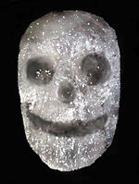
For the Love of God, D. Hirst, 2007 Spiritus Callidus, John LeKay, 1993,
17 x 12 x 19 cm. Size unknown
For The Love of God was first displayed at the White Cube Gallery in an exhibition called Beyond Belief, and yet again inciting accusations of plagiarism,
Hirst claimed that the idea for his work came from an Aztec skull at the British Museum (Thompson, 2012 p75-76). However, artist John LeKay, a friend of Hirst's in the early 1990s, and the victim of a number of Hirst plagiarisms, said the work was based on a skull covered with crystals which he had made in 1993, saying:
’It has become impossible to show my own work, Because now everyone who sees it now says it looks like a Damien Hirst artwork. It appears that Damien thought that when I walked away from the art world back in 95, that gave him carte blanche to take anything he wanted. Maybe he saw it as free pickings, sifting through my work like a vulture. It was my stupidity to allow him into my studio all those times to see my work. I should have known better.’ (Thomson, 2010).
One way of analysing this is that Hirst believes he can plagiarise whatever he wishes and he sees himself as invincible because of the power of his money. For the Love of God, shows Hirst’s talent as an appropriator, presenter and dealer, but one view could be that the exorbitant cost should not make it a work of art.

3.4.3. THE SALE.
Valued by Hirst at £50 million, he insists that it was sold to a Global Group of collectors, which included himself, for £50 million. It is not known how much Hirst contributed himself, but it is commonly believed that the skull was never sold. (Lee, 2010). David Lee, editor of The Jackdaw, commented:
‘Everyone in the art world knows Hirst hasn't sold the skull. It's clearly just an elaborate ruse to drum up publicity and rewrite the book value of all his other work.’ (Lee, 2010).
This covert sale occurred shortly before his restaurant sale in 2008 and can be seen as an astute commercial decision to inflate the value of his work in expectation of the direct auction at Christy’s. The financial drive for this work can therefore be analysed as another of Hirst’s ‘look at me’ masquerades to undermine and exploit the art-world, in a conceited attempt to rescue his flagging sales (Lee, 2010).

CHAPTER 4. CONCLUSIONS.
A NEGATIVE VIEW.

If money is a measure of success then Damien Hirst might be hailed as a hero. However, artistic merit cannot be measured by money alone, and Hirst’s commercial focus and plagiaristic nature are factors which question his artistry.
Throughout his career, money has motivated Hirst to exploit the talent of other artists, and offer no acknowledgement or credit for their creativity. In addition to the appropriation, it can be observed that the commercially driven Hirst has:
Firstly: As one of ‘Thatcher’s Children, been a willing victim of the immoral socio/economic environment of the 80’s and 90’s, where money mattered.
Secondly: Achieved enormous wealth by his opportunism, immaculate sense of presentation, and self-centred arrogance.
Thirdly: With his ‘look at me’ bullying, egotistic disregard for other peoples’ rights, he has exploited the art-world for his personal financial gain and rebuffed his creator Charles Saatchi.
Perhaps the most vulgar example of all of this greed is encapsulated in just one of Hirst’s works, For The Love of God.
One analysis could be that the work is a loutish boast of wealth by a clever technician who, not for the first time, copied and exploited the creative energy of another artist, contributing little of himself apart from his Brand, his wealth and acute sense of commercialism.
We should question why the establishment, of internationally renowned auction houses, galleries and museums, accepted and legitimised Hirst’s Brand of con art and plagiarism, without hesitation. Had it not been for Saatchi’s branding genius, Hirst may never have gained a foot on the first rung of the ladder, but he has been applauded as the principal icon of today’s conceptual art-world and exalted as an example to thousands of art students.
One view could be that the art establishment was seduced and corrupted by the enormous sums of money associated with the sale of Hirst’s work. That is immoral and should never be the motivation or measure for artistic merit.
A critical view is that the net result of all the greed and exploitation could now signal the end of Hirst’s Brand of tired, old, readymade, elitist, pretentious, conceptual deception. Much of which is better suited to the Natural History Museum, than the Art Museum.
Conceptual Art is now 25 years old and we should look forward to the next chapter of real art, which will hopefully celebrate the morals of originality, integrity, colour, skill, and craftsmanship.

APPENDIX 1. “THE ART DAMIEN HIRST STOLE.” (Thomson, 2010).
The images illustrated below, highlight a selection of Hirst’s appropriations from his contemporaries, and exploited in some of his most financially successful works.

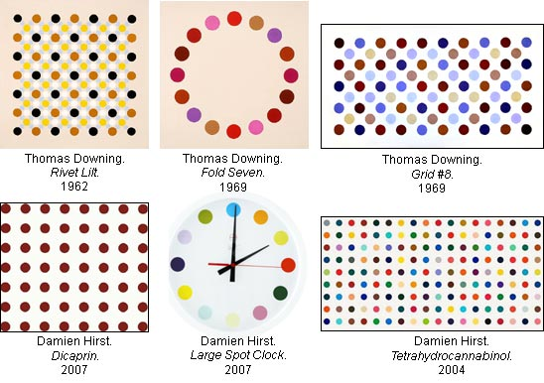
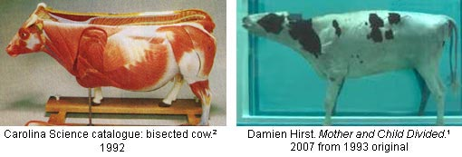
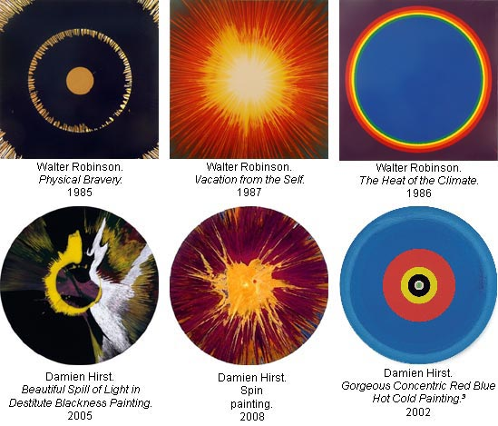
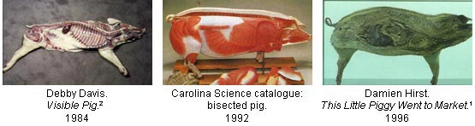

APPENDIX 1. (continued).

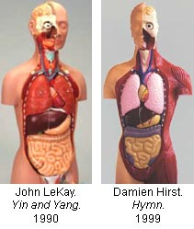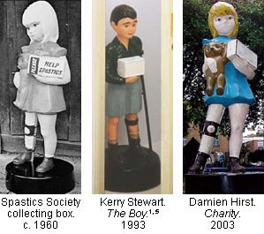

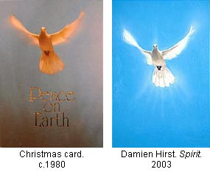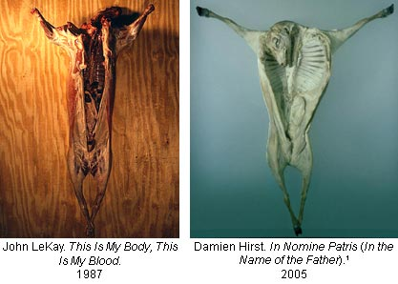

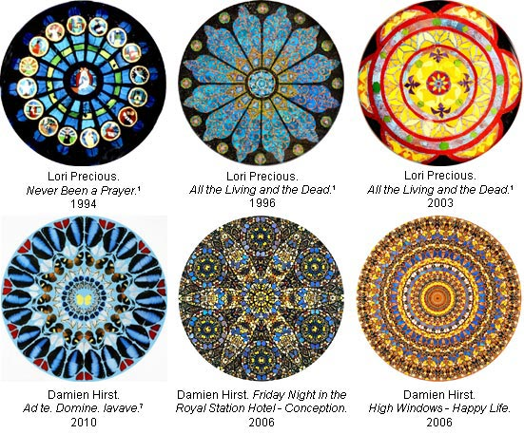
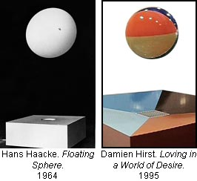
BIBLIOGRAPHY: (536 words of )
Anderson-Spivy A. (1998) ‘The Freeze Generation and beyond.’ Art Journal Review Vol. 57,
Archer M. (2002) Art Since 1960. Thames and Hudson, London.
Batty D. (2013) ‘Damien Hirst's split from Larry Gagosian turns heads in art world.’ The Guardian.

Bennett W. (2004) ‘Hirst makes millions in clearance sale of his chemist shop.’ The Telegraph Oct.

Benjamin, W (1935) ‘The Work of Art in the Age of Mechanical Reproduction.’ Penguin London, 2008.
Blayney, D. (2012) Tate website. December 2012
Christys.com (2014) website article.
Cicelyn E. (2004) Damien Hirst, The Agony and Ecstacy, Works from 1989 to 2004. ‘Naples Museo.’
Coman, J (2013) ‘Margaret Thatcher: 20 ways that she changed Britain’. The Guardian April 2013.

Dannatt A. (1993) ‘Life’s Like This and Then It Stops’, Flash Art, no.169 page 59,
Dorment R. (1992) ‘Art review’ The Daily Telegraph published in on March1992.
Freeland C. (2001) But is it Art? Oxford University Press, New York.
Fallon I. (2007) ‘Saatchi & Saatchi: The agency that made Tory history.’ The Independent Sept 07
Gallagher A. (2011) ‘Article’ Encyclopaedia Britannica.
Gallagher A. (2012) Damien Hirst . Tate Exhibition Catalogue Tate Publishing,
Gibbons, F. (2002) ‘Arts page’ The Guardian, Tuesday 5 February 2002
Hirst D and Burn G (2001) On the Way to Work. Faber and Faber, London
(2012) available at: www.damienhirst.com/texts1/series/spots.

(2007) available at: www.damienhirst.com/texts1/series/for the love of god.
Hopkins D. (2000) After Modern Art. Oxford University Press, New York.
Howarth, S. (2000) ‘Tate Article’ available at: www.tate.com.
Hudson, M. (2014) ‘What is the point of the Turner Prize?’ Telegraph Dec 2014
Hughes R. (2004), ‘Royal Academy Dinner Speech.’ Evening Standard 3rd June, 2004.
Janás R. (2009) The Stuckist Decade 1999 – 2009. Stuckism International: Victoria Press, London.
Jones Jonathan. (2013) ‘Art page.’ The Guardian October 2013
Lee, D. (2010). ‘Art newsletter’ The Jackdaw. September 2010.
Lydiate, H. (2010). ‘Credit Where It's Due.’ Art Monthly, Issue 340.
May E. (2000) ‘Tate Modern Review.’ available at: www.tate.com May 2000.
Mcintyrte, M. (2004) How to cultivate the art market. Arts Council Taste Buds.
Morgan, S. (1996) ‘Interview with Damien Hirst,’ available at: www.damienhirst.com/texts/1996
Muir, G. (2009) Lucky Kunst, the rise and fall of young British art. Aurum Press London.
Muir G / Wallis C (2004) In-A-Gadda-Da-Vida. Tate Publishing, London.
Rowe, A (2011) ‘Appropriation in Contemporary Art.’ Hayley Vol. 3 No. 06
Saatchi C (2009) My name is Charles Saatchi and I’m an Artoholic. Phaidon Press, London.
Seed J (2014) Ten Eccentric Essays on Art. Create Space Independent Publishing Platform 2014.
Self W. (2007) Hirst, Beyond Belief. White Cube, London.
Smart, R. (2012).Telegraph, March 2012
Spalding J. (2011) Con Art why you should sell your Damien Hirsts while you ca. Amazon/Kindle.
Spalding J. (2003) The Eclipse of Art. Prestel Publishing, London.
Stellabrass J. (1999) HighArt Lite. The rise and fall of Young British Art. Verso Books, London; New edition 2006.

(2010) ‘TateShots Billy Childish.’ available at: Sound & Vision: Part 5 Feb. 2010.
(2007) ‘The Young British Artists (YBA’s).’ tatelearn.available at: www.tate.com.
(2012) ‘Tate Video.Walkthrough with Ann Gallagher and Damien Hirst.’ available at: www.tate.com.
Thomson, C. (2010) ‘The Art Damien Hirst Stole’ Article by Stuckist co-founder, London Art network.
Thompson, D. (2008) The $12 million Stuffed Shark. Aurum Press, London.
Thompson, G. (2012) ‘Jemanden ein R Mutt’s zeugnis ausstellen, Monsieur Goldfinch.’. Wild Pansy Press, Apṙil, 2008,
Thornton S, (2008) Seven Days in the Artworld. W. Norton, London.
Tomkins, C. (1996) Duchamp: A Biography, Henry Holt and Company.
VOGEL C. (2006) ‘Swimming With Famous Dead Sharks.’ New York Times.
Wolfe T. (1987) “Painted Word.” Picador USA.

No images found
See pages 14.
See page 21.
See Appendix 1.
See Appendix 1.
See page 12.
See page 26-Sect 3.4.3.
See pages 22-23.
See appendix 1..
See appendix 1.
See page 12.

